

**SECP1513-02 TECHNOLOGY AND INFORMATION SYSTEM**

**DESIGN THINKING PROJECT REPORT**

**TITLE: ENERGY USAGE AND SUSTAINABILITY**

**GROUP 4: SYNTECH**

**PREPARED FOR: DR. ARYATI BINTI BAKRI**

Group Members:

|  |  |  |
| --- | --- | --- |
| SHASYA SHAFIEQAH BINTI SHAHARUDDIN  A25CS0350 | YONG SEE EN  A25CS0168 | BALQIS BATRISYA BINTI JALALUDDIN  A25CS0196 |

CONTENTS

1.0 INTRODUCTION 3

1.1 Background 3

1.2 Purpose 3

2.0 DETAIL STEPS 4

3.0 DETAIL DESCRIPTION 5

3.1 Problem 5

3.2 Solution 5

3.3 Team Working 6

4.0 DESIGN THINKING EVIDENCE 7

4.1 Sample Work 7

4.2 Record for each phase 9

4.2.1 Empathy 9

4.2.2 Define 12

4.2.3 Ideate 18

4.2.4 Prototype 19

4.2.5 Test 22

5.0 REFLECTIONS 23

6.0 TASK DISTRIBUTION 26

7.0 CONCLUSION 26

8.0 REFERENCE 27

9.0 VIDEO 27

# 1.0 INTRODUCTION

## 1.1 Background

According to official academic information that publish by University Teknologi Malaysia (UTM), it stated that UTM has 12 of Faculties. (Universiti Teknologi Malaysia, n.d.) faculties offer a variety of learning spaces, such as lecture halls, tutorial rooms, laboratories, and seminar room, which support students’ daily academic activities. As a result, classrooms play a major role in overall campus energy usage due to the continuous operation of lighting, air-conditioning, audio and visual equipment along with other electric appliances. While it is impossible to eliminate this energy use entirely as, it can be reduced. So that to solve the problem, our team decides to develop a thermal imaging sensor device called “ThermiQ”, design to assist UTM staff especially UTM technical staff in saving energy.

## 1.2 Purpose

The purpose of this project is to identify how energy is currently being used in classrooms on campus since energy wastage is a common problem nowadays. This project is aiming to design a system that can automate the control of lights, air-conditioning, and other equipment based on room occupancy so that the electricity use and energy wastage can be reduce. Therefore, thermal imaging sensor is created to accurately detect the real human presence. On top of that, this project is supporting university's sustainability initiatives and applying the data-driven method to tackle the real problems. It will also enhance the energy efficiency without disrupting daily learning activities.

# 2.0 DETAIL STEPS

|  |  |
| --- | --- |
| Empathize | Firstly, we carried out a survey to collect data for understanding the issues faced by our users and their opinions on the features through google form. At the same time, we also conducted a face-to-face interview with a UTM staff, Mr. Mohd Idzham Iqbal to explore deeply the problems occurring in the UTM campus. |
| Define | All the data collected from the empathize stage were analysed during our discussion. From the survey, we finally understood the existing issues faced by our users and their desired additional features. Our challenge is the electrical equipment continuously operating even after the class has ended, where it leads to higher energy consumption and energy waste. |
| Ideate | Several potential solutions have been suggested to address the identified problem, including thermal sensor, energy monitoring application, smart timetable, motion sensor auto shut off, and overload protection. Thermal sensor is selected as the most suitable solution due to the ability to detect human presence accurately. Another solution being chosen is matric card reader, detecting the presence of matric card to turn on the individual electrical equipment such as desktops. |
| Prototype | In this phase, we created a prototype by designing the interface and mock-up using Canva. We incorporated the users’ desired features into our prototype to better address their needs and expectations. |
| Test | Finally, we test the prototype to make sure our product can function smoothly. At first, the first test was conducted by our team to detect any errors that might affect the functionality, accuracy, or usability of the prototype. After that, we invited some students to use the prototype and provide feedback on its usability, clarity, and effectiveness in promoting energy-saving behaviour. In this phase, we got to improve our product based on the users’ feedback. |

# 3.0 DETAIL DESCRIPTION

## 3.1 Problem

There are several problems identified in this project, which are air-conditioning and lights remain switched on in empty classrooms, individual electrical equipment is not properly shut down after been used, and all electricity is turned on even there are only few students in a classroom. As a result, a large amount of energy is used unnecessarily.

Based on data collection, although most of the users practice energy saving, there are still many of them who did not care much about energy usage when leaving the classroom. This is mainly because they are assuming others will do it instead of themselves, and if this mindset keeps going, the problem will never be solved. On top of that, energy wastage also happened because some of them are in a hurry and forget to do so.

## 3.2 Solution

Our team had proposed a solution to create a device that can help students and staff in saving energy without thinking about switch off the lights and other equipment manually. Based on our respondents’ choices, most of them choses motion sensor auto shut off as the features that they find most useful. From that, we upgrade it to thermal imaging sensor because motion sensor only responds to physical movement.

Thermal imaging sensor or “ThermiQ” is personally created to detect human temperature, where it can show whether the room is occupied or not. Our “ThermiQ” can also identify the exact area in the room that is being occupied by students and lecturer. This allows the device to manage energy usage more efficiently based on the real occupancy.

Another solution that we had proposed is matric card reader, where students need to put their matric card at the provided place in order to use the individual electrical equipment. Without being able to do so, they cannot use the equipment, at the same time they will become more alert and realize that the matric card is important in their daily life as a student. Therefore, the classrooms facilities can be controlled more effectively to reduce energy consumption.

## 3.3 Team Working

Our group have worked together by dividing roles and responsibilities in finishing this project. We mainly communicated through WhatsApp and meet regularly to discuss progress, brainstorm ideas and share the ideas with one another. Each member has different ideas, and we discussed it together to decide which idea is the most suitable or combine several ideas to produce a good result. On top of that, strong team dynamics enable individual members to divide complex projects into manageable tasks (Team Asana , 2025). This project helped a lot in building a great teamwork.

# 4.0 DESIGN THINKING EVIDENCE

## 4.1 Sample Work

|  |  |
| --- | --- |
| **Empathy** |  |
| **Define** |  |
| **Ideate** |  |
| **Prototype** |  |
| **Testing** |  |

## 4.2 Record for each phase

### 4.2.1 Empathy

Our team member, Shasya Shafieqah Binti Shaharuddin conducted an interview with Mr. Mohd Idzham Iqbal, which is a UTM technical staff at Faculty of Computing. From this interview, we obtained his view on energy wastage as well as his role as technical staff in manage and control it. We also interviewed a student, conducted by our team member Yong See En, to gather her opinion on energy wastage. Besides that, we also conducted a survey to collect and gather not only the issues faced by our users but also their suggested additional functions and features in campus energy by using google form.

**User Research Summary**

* Target users: UTM students and UTM staffs
* Methods: Face-to-face interviews and Google Form
* Key findings:
* Do not regularly monitor energy usage
* Lack tools to track consumption
* Electrical appliances remain on in empty classrooms

**Composite character**

**Age:** 19

**Background:** UTM student

**Goals:** - To practise sustainable energy usage

- To reduce environmental impact and carbon footprints

-To avoid wasting electricity when electrical appliances are not in use

**Problems:** -Packed timetable causes users to rush between different classrooms

- Forget to switch off all the electrical appliances when leaving classrooms

- Assume others will switch off the equipment

- Feel it is not their responsibility

**Behaviours:** - Rarely switch off electrical appliances after leaving classrooms

- Hesitation to switch off equipment due to unclear responsibility

**Interview questions**

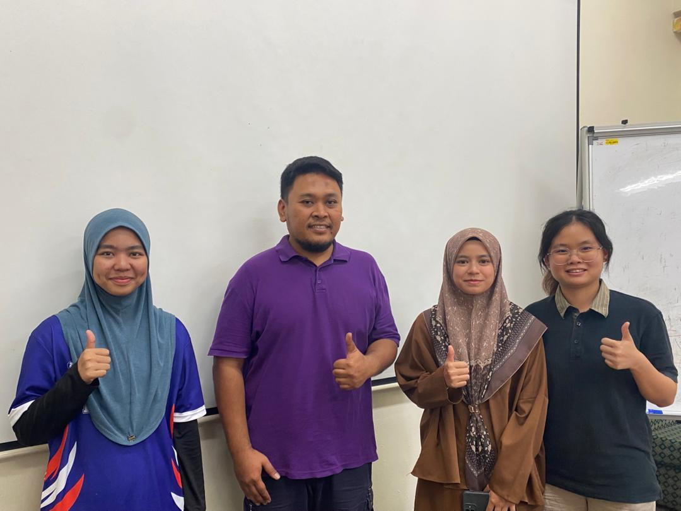

Figure 1: Interview with Mr. Mohd Idzham Iqbal

1. What common energy wastage issues staff encounter in classroom?
2. Is there a schedule or routine for checking classrooms to ensure equipment is switched off?

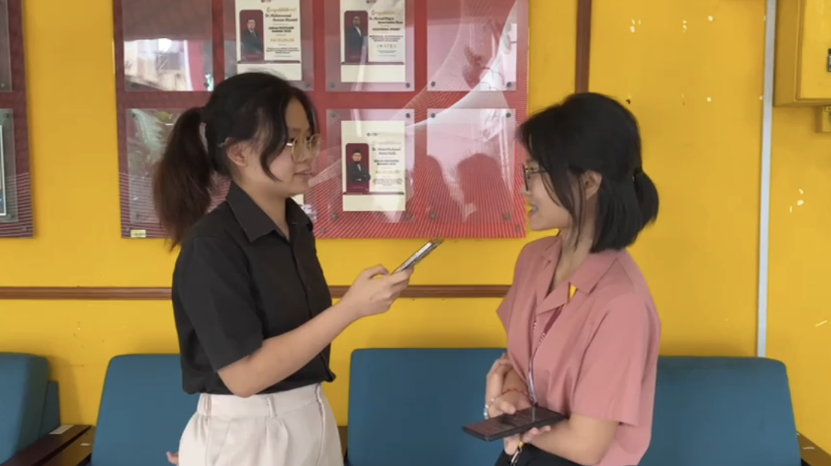

Figure 2: Interview with student from Faculty of Computing

1. Does seeing energy waste affect your perception of the university’s sustainability efforts? And why?
2. What are the most common energy wastage issues you observe on campus?

|  |  |
| --- | --- |
|  |  |
|  |  |

Figure 3: List of questions for Google Form

### 4.2.2 Define

In this phase, we collected all the data that obtained from the interview sessions and Google Form survey. This helped us to clearly identify and understand the issues they faced, which allowed us to design a more effective solution that addresses the problems and fulfils their needs. After analysing the data and opinions obtained, we understood that the users struggle to manage energy usage in lecture halls, tutorial rooms, laboratories, and seminar room due to lack of awareness of energy sustainability practices, have a packed timetable and often feels it is not her responsibility to switch off shared equipment. This leads to energy wastage and increase in carbon footprints.

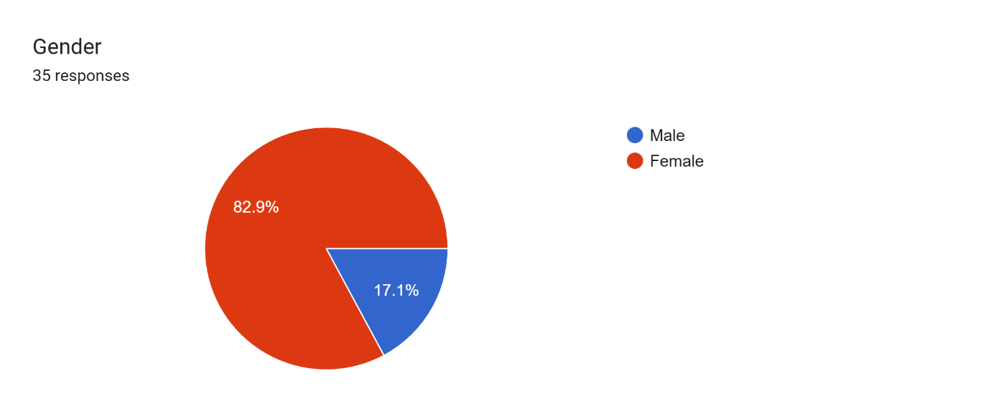Figure 4

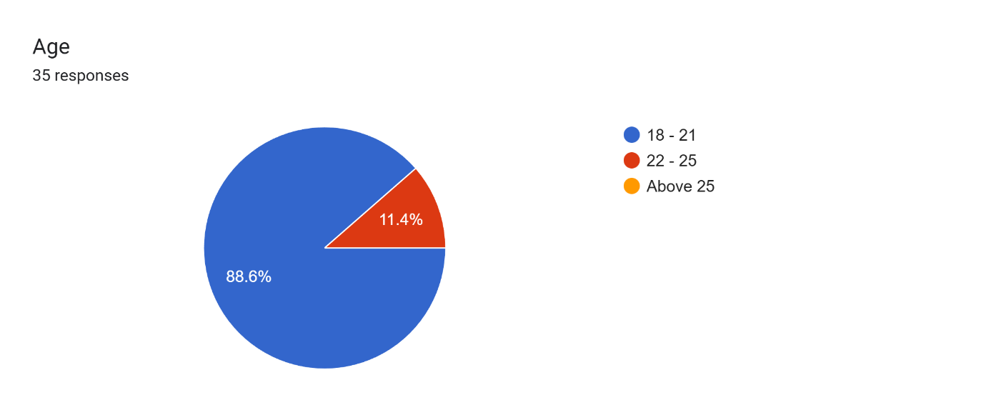

Figure 5

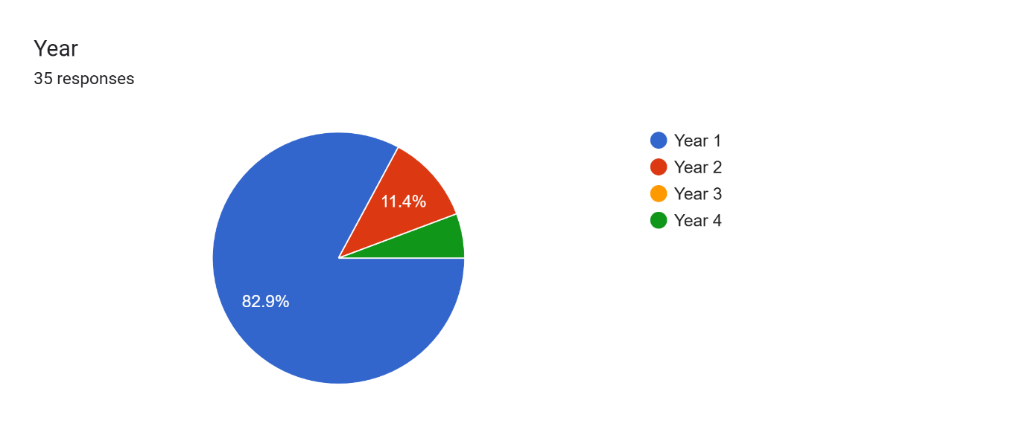Figure 6

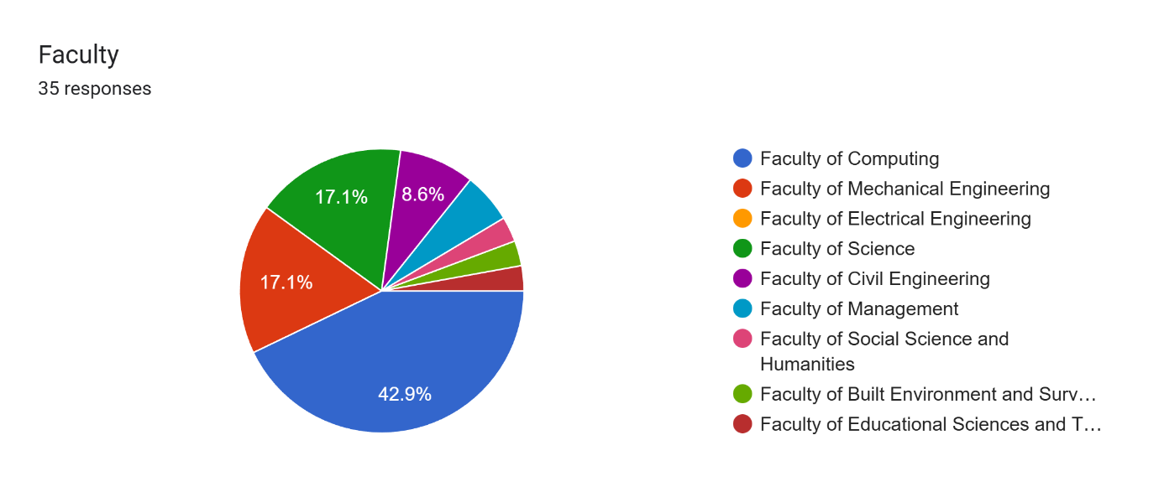Figure 7

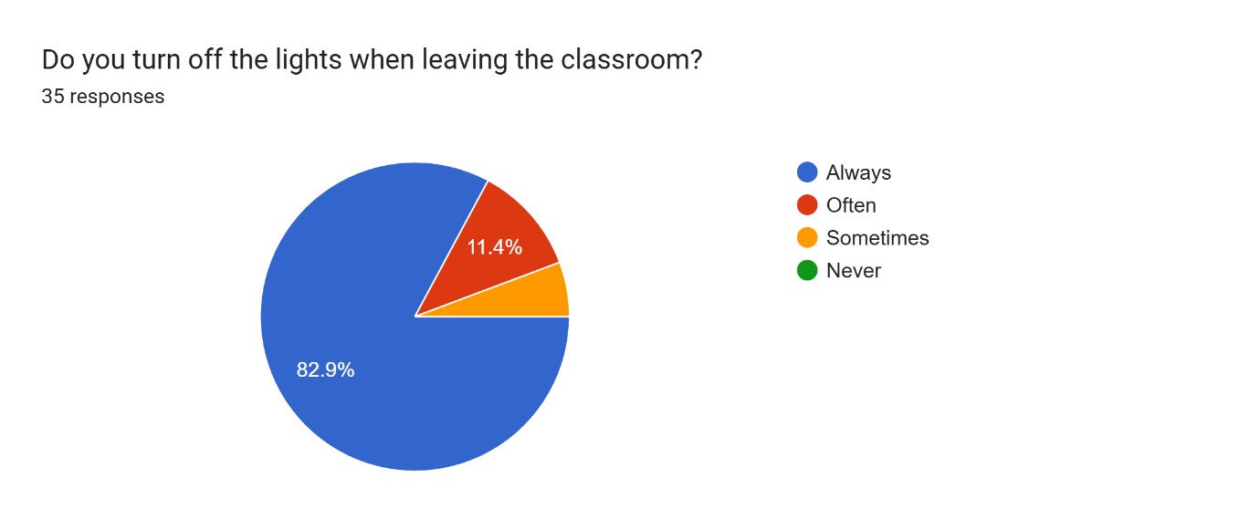Figure 8

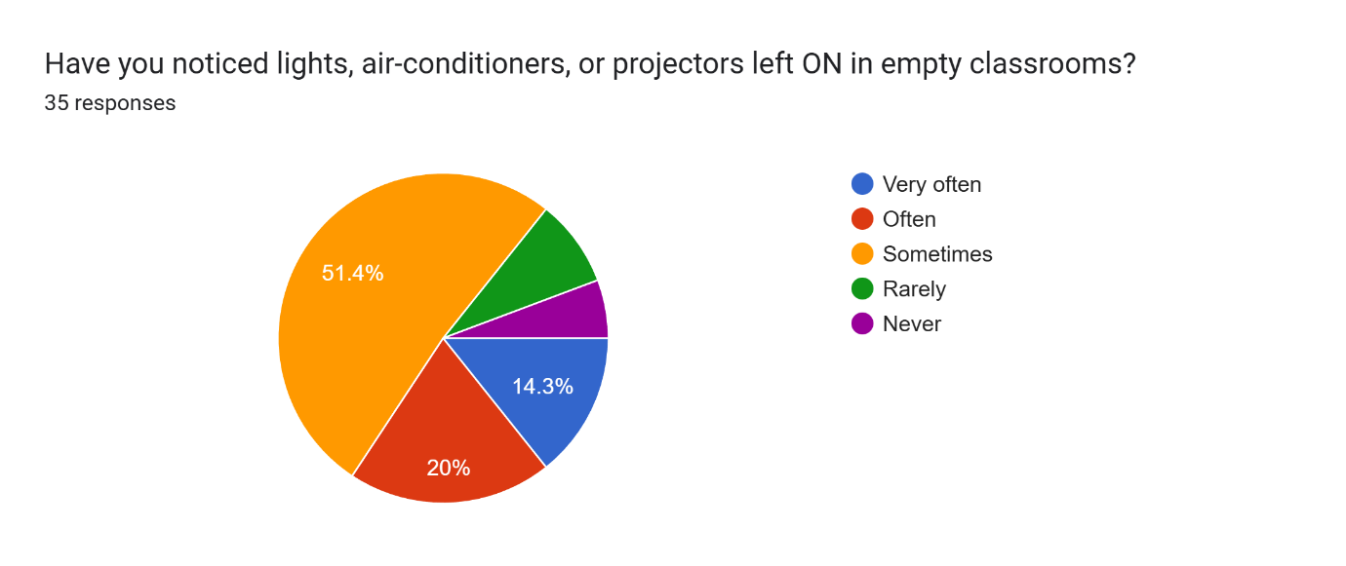

Figure 9

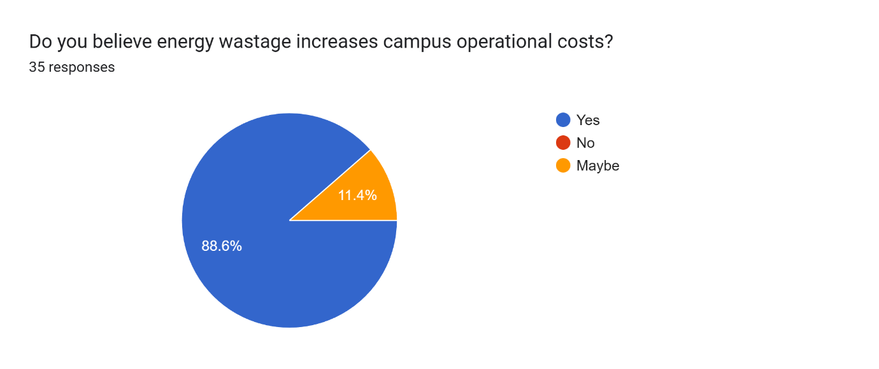

Figure 10

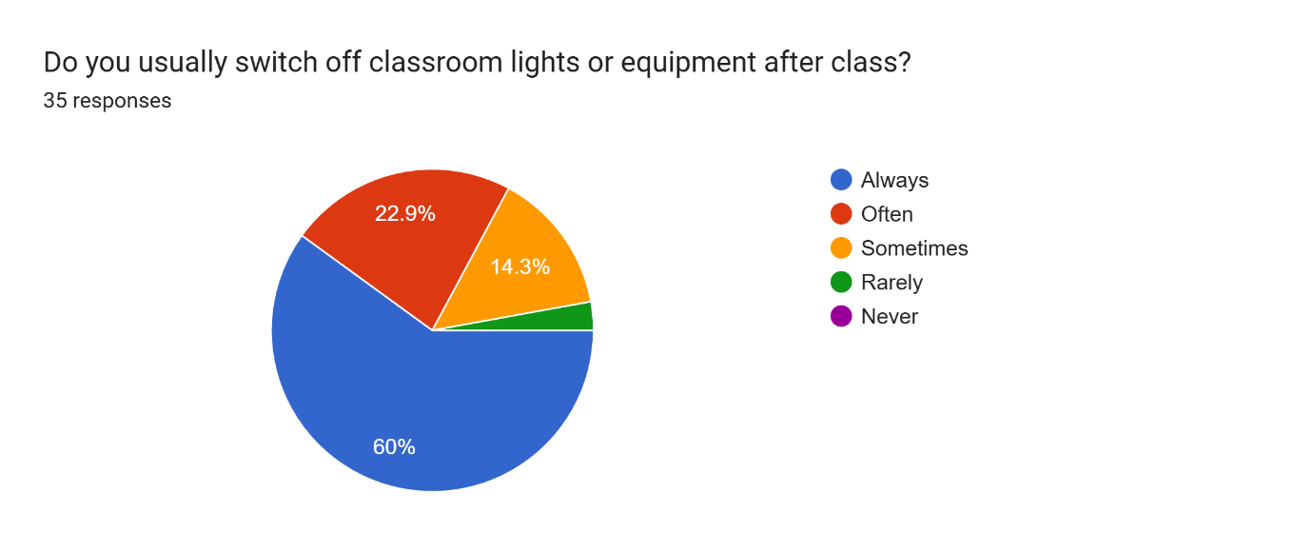

Figure 11

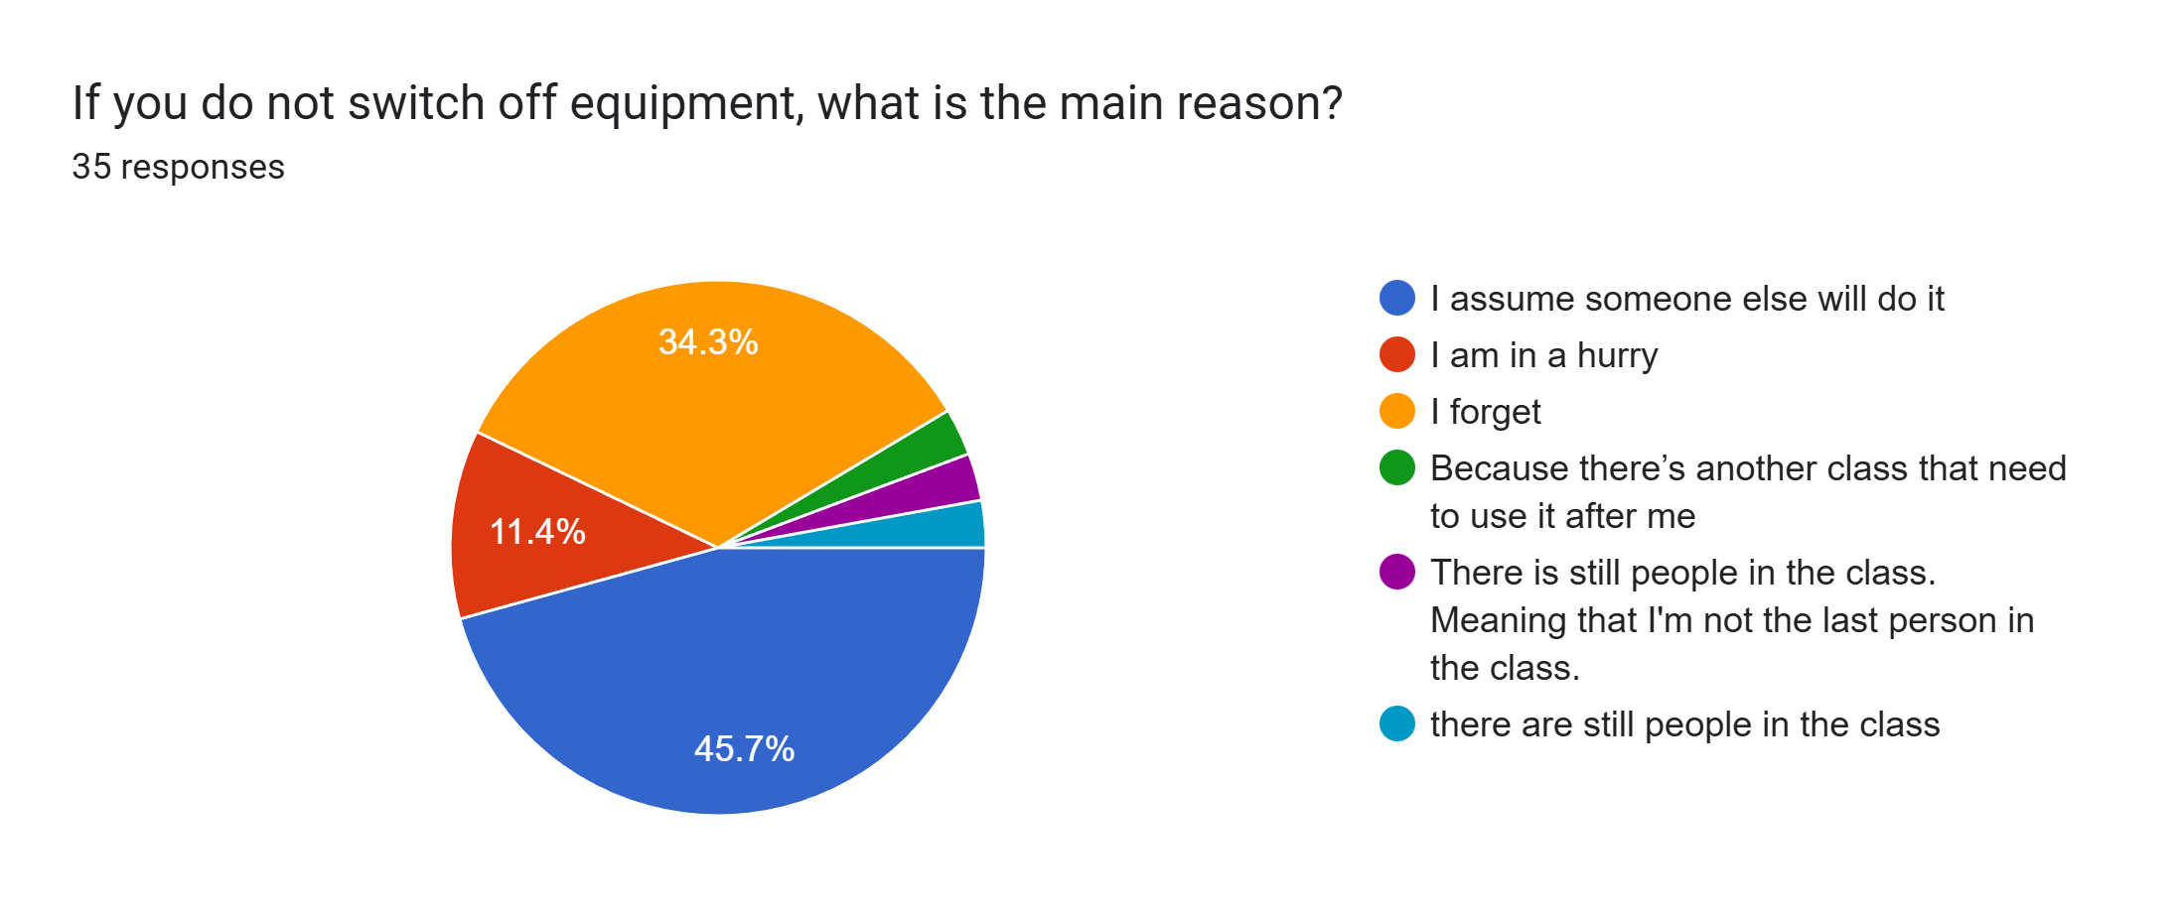Figure 12

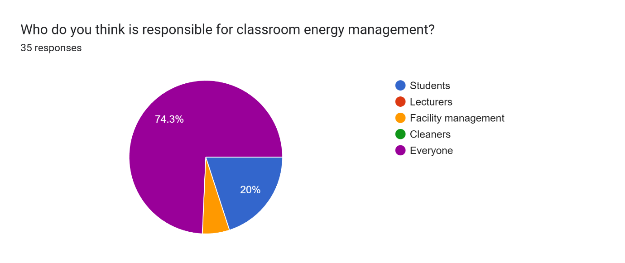Figure 13

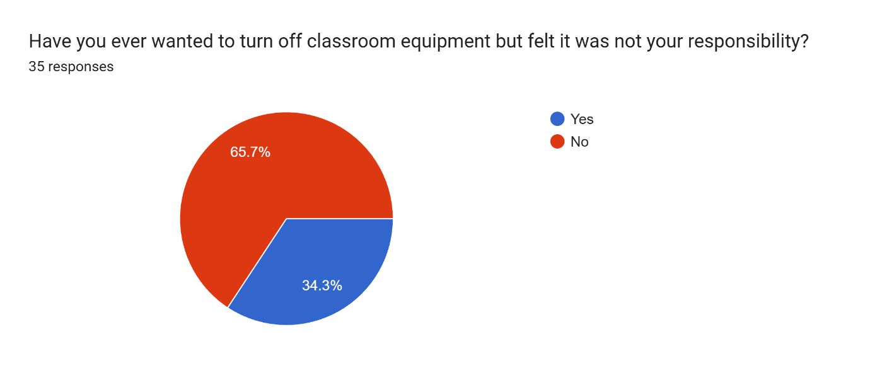Figure 14

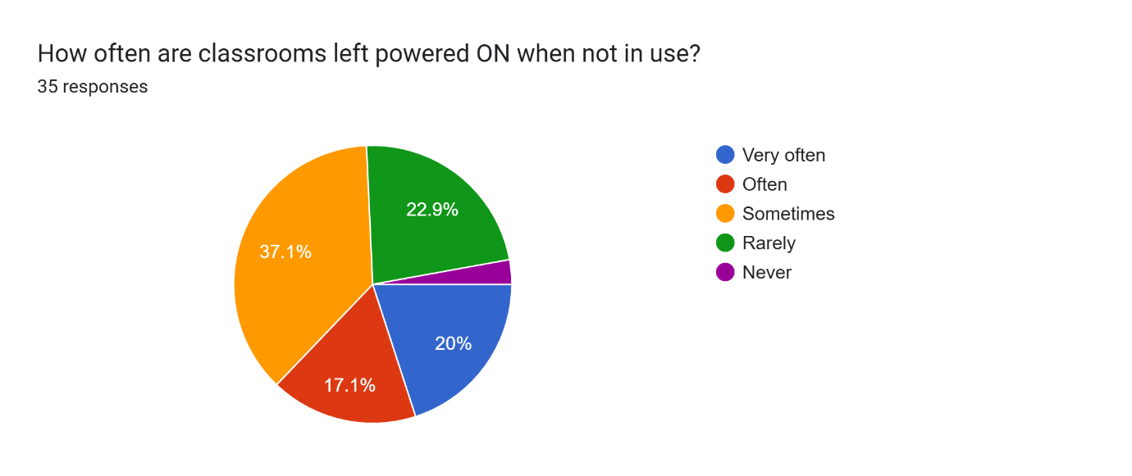Figure 15

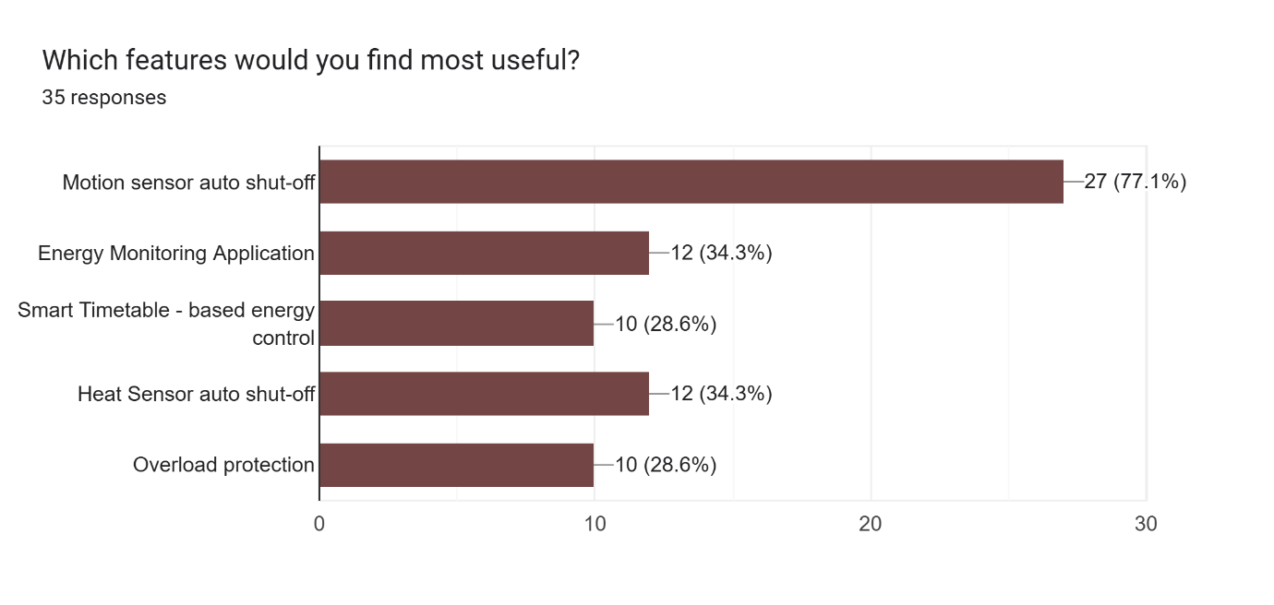Figure 16

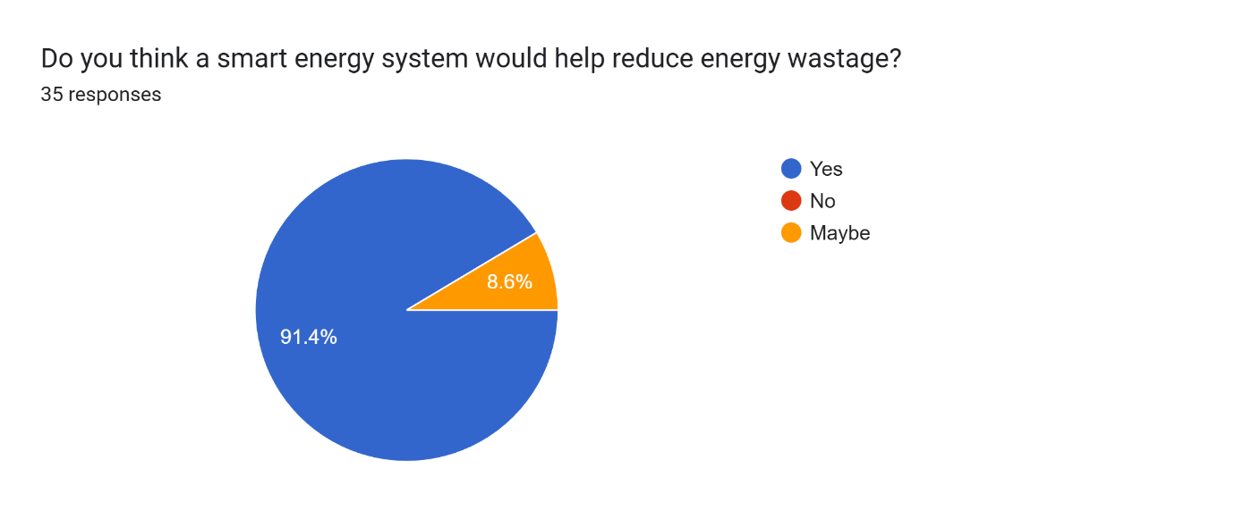Figure 17

Figure 4-17: Chart of response

**Journey Map**

|  |  |  |  |  |
| --- | --- | --- | --- | --- |
| **Stage** | **Actions** | **Problems** | **Emotions** | **Solutions** |
| Before Class | When enters classroom, lights and air-conditioners already on | Lack awareness of energy usage | Indifferent | Checks classroom condition and turns off unnecessary electrical appliances if low temperature is detected |
| During Class | Use lights, air-conditioners, projector | Uses many unnecessary electrical equipment | Comfortable | - Detects human body temperature and automatically turns on electrical appliances  - Desktops will only being turned on when detects presence of matric card |
| After Class | Rushes to next class | Forget to switch off the electrical appliances | Stressed, nervous | Detects low temperature and automatically turns off unnecessary electrical appliances after class |
| Leaving Classroom | Notices all the equipment remain on | Hesitate if it is their responsibility | Confused, hesitant | No human body temperature is detected, turns off the equipment in 120 seconds |
| End of Day | Reflects on energy usage | Realises energy wastage and increase in carbon footprint | Concerned, guilty | Provide a summary of daily energy usage |

### 4.2.3 Ideate

After understanding the issues faced by our users, we held several meetings to brainstorm ideas and solutions dealing with the issues. Through the several meetings, we finally decided to add thermal imaging sensor feature into our product. Thermal imaging sensor detects and visualises the heat which is the infrared radiations emitted by human to determine the appropriate time to switch off the electrical appliances in order to reduce energy wastage. Other than that, our team also create a product called matric card sensor. It will turn on the desktops once the students’ matric cards are inserted.

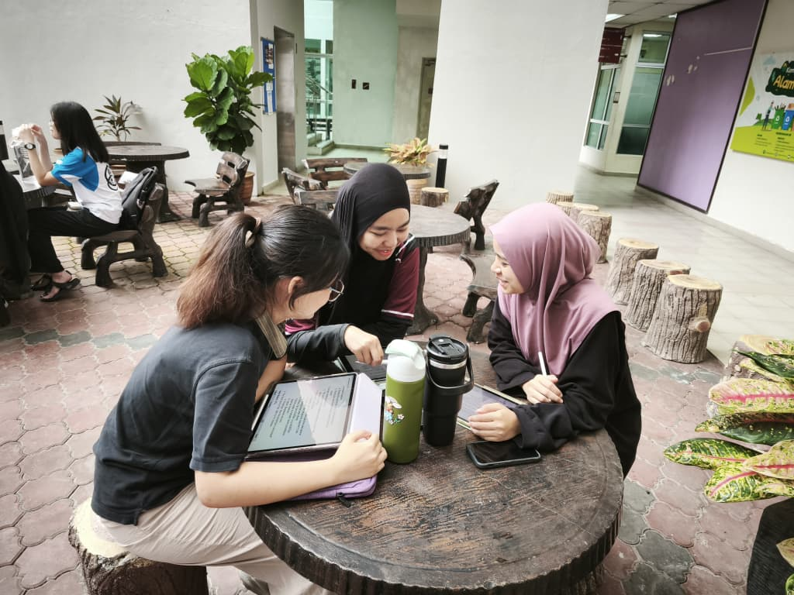

Figure 18

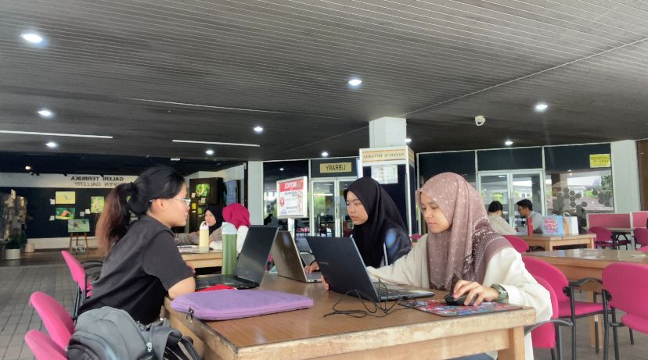

Figure 19

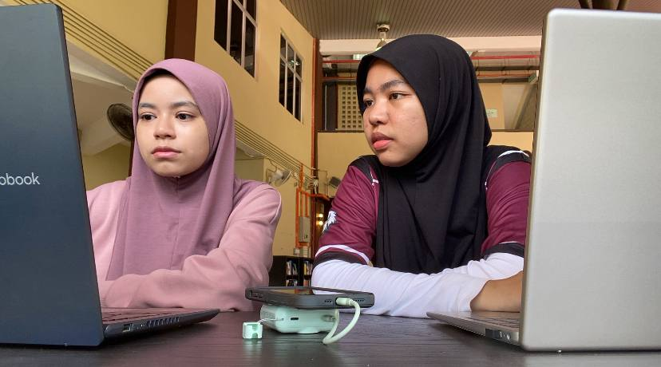

Figure 20

Figure 18-20: Discussion Session

### 4.2.4 Prototype

In prototype phase, our team applied all the data, ideas and opinions collected from the previous phases as the guidance for creating our prototype.

**“ThermiQ”**

|  |  |
| --- | --- |
|  | ThermiQ will show “NO” to indicate that no human body temperature is detected. |
|  | ThermiQ will show “YES” to indicate that human body temperature is detected. |
|  | Once human body temperature is detected inside the classrooms, ThermiQ will start to countdown from five to one. |
|  | After countdown, ThermiQ will turn on the electrical appliances such as lights and air-conditioner based on the presence of people in specifics area. Lights and air-conditioner in area D are switched on due to the presence of people. |
|  | Lights and air-conditioner in area A and E are switched on due to the presence of people. |
|  | When no body temperature is detected, ThermiQ will start a three-minute countdown. If no one is detected during this period, lights, air-conditioners and projector is automatically turned off. |

**Matric Card Reader**

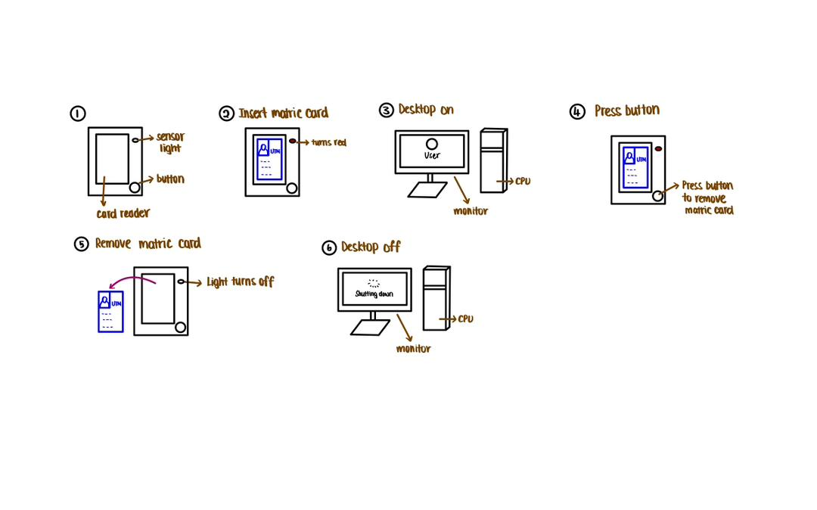

|  |  |
| --- | --- |
| **STEP** | **DESCRIPTION** |
| 1 | The sensor light will turn green to indicate that there is no obstruction and allowing the user to insert their card. |
| 2 | When the card is inserted into the card reader, the sensor light will turn red to notify the user that the card is insert correctly. |
| 3 | The card reader will immediately read and verify the user’s identity. If verify as UTM student, the assigned PC will automatically turn on. |
| 4 | After the user finish using the PC, instead of pulling the card from the reader, they can press the button safely and release the card. |
| 5 | The sensor light will turn back green to indicate that the user’s card has been release correctly without any issues. |
| 6 | When the card is removed, the system will safely log out and turn off the PC automatically. |

### 4.2.5 Test

During the testing phase of the prototype, we asked several users to try out our products. Most of them gave positive feedback about the prototype and commented that our products are very useful to ensure energy sustainability and reduce carbon footprints.

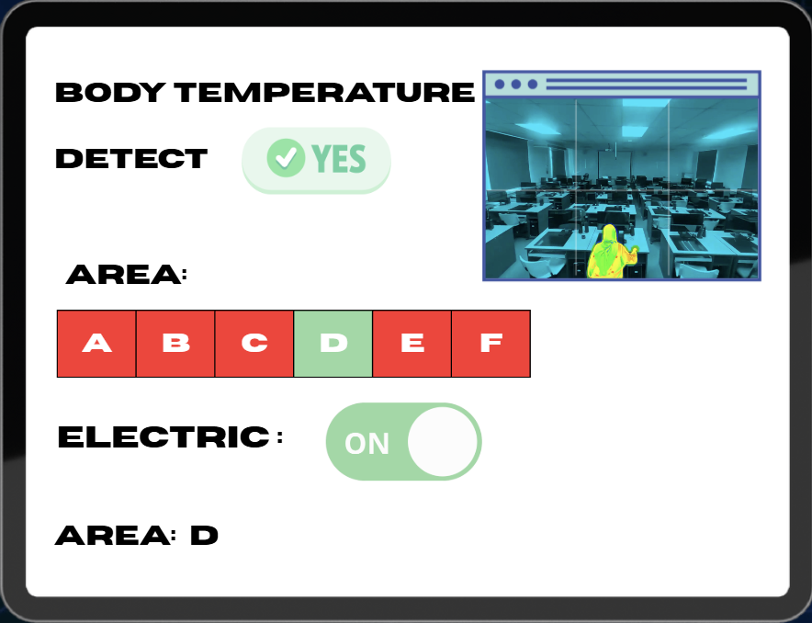

Figure 22

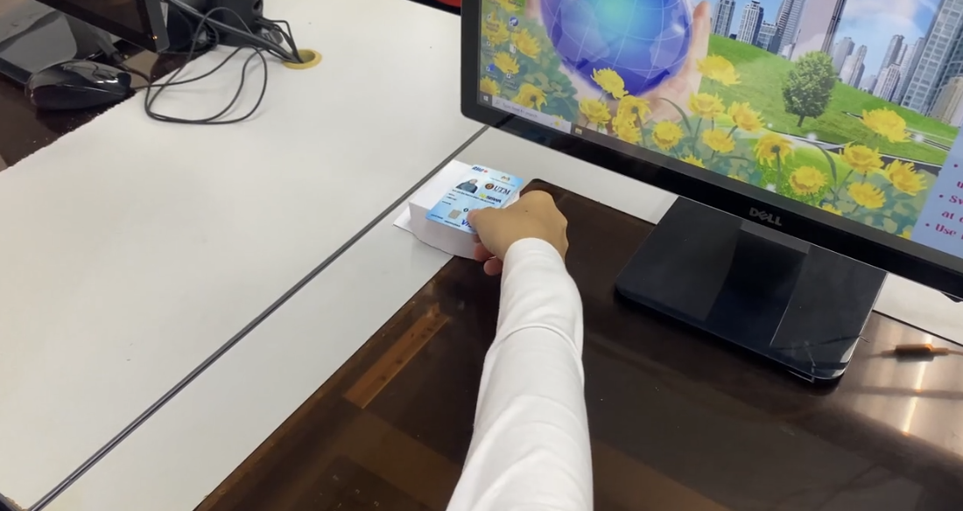

Figure 23

Figure 22-23: Testing Prototype

# REFLECTIONS

|  |  |
| --- | --- |
| **SHASYA SHAFIEQAH BINTI SHAHARUDDIN (A25CS0350)** | 1. Working with computers has been my dream since I first started learning courses that involved the use of computers in my secondary school, so my goal is to develop my skills and understanding in the field of computing, as I have a strong interest in exploring how computer systems and technologies work. 2. By conducting surveys via Google Forms and interviews with students and staff, I was able to gather real data and understand practical challenges related to energy at our campus. Furthermore, preparing the report and progress video helped me enhanced my computing and analytical skills in a real-world context. This experience supports my goal of developing practical computing skills and understanding how technology can be applied to solve real-life problems. 3. I plan to strengthen both my technical and soft skills. For soft skills, as I know that my communication skills need improvement, I plan to actively involve myself in various activities, such as group projects, workshops, and presentations, to enhance them. Additionally, for my technical skills, I aim to improve in areas like programming and data analysis through courses, practical projects, and internships. By doing so, I hope to be better prepared for a future career and contribute effectively to technological and security advancements. |
| **YONG SEE EN**  **(A25CS0168)** | 1. My goal with regard to my course, which is data engineering is to apply all the techniques and skills I learned throughout my four-year university journey. I aim to become a competent and skilled data engineer who can develop creative and well-structured solutions to solve real-world problems and manage large projects. Hence, I need to build a strong fundamental and deeply understanding all the knowledge gained during the four years of university. 2. This design thinking project helps me gain a deeper understanding of the requirements of users and how to design solutions to solve them. Throughout this project, I learned how to analyse users’ needs, apply critical thinking skills and problem-solving skills to solve a real-world issue. Not only that, since this is a group project, I learned how to communicate with group members to gather and integrate all the ideas to design a functional solution that fulfil the requirements. 3. To improve my potential in the industry, I plan to enhance my technical skills and programming skills such as C++, HTML and Java. A strong foundation on the core academic courses is essential as it acts as a stepping stone in the industry. I need to do continuous research to ensure that I keep up with the latest developments in the fast-paced technology era. Apart from that, soft skills like communication skills, debating skills and presentations skills should be mastered so that I can clearly explain my projects to the company or individuals with insufficient data-related knowledge. Thus, I plan to involve myself into more activities and programmes that able to train my speaking skills. |
| **BALQIS BATRISYA BINTI JALALUDDIN**  **(A25CS0196)** | 1. My goal regarding my course is to gain deeper knowledge and skills that will prepare me for real-world challenges. I want to strengthen my understanding of the concepts that I learn, so that I can apply them confidently in my practical situations. 2. This design thinking project is impacting my goal because it helps me in improving my problem-solving and critical thinking skills, where these skills are really important in industry world. I also get to improve my teamwork, research and prototyping skills, which it is essential for my professional development. 3. In order to improve my potential in the industry, I need to practice applying the design thinking concepts in my projects and assignments during my studies. Other than that, I plan to master all programming skills during my four-year degree journey, as it is a core skill that is very important to computer science students. I also need to continuously developing my technical and soft skills especially communication and teamwork as these skills are highly required in industry. |

# 6.0 TASK DISTRIBUTION

|  |  |  |
| --- | --- | --- |
| **No.** | **Group Members** | **Tasks** |
| 1. | Shasya Shafieqah Binti Shaharuddin  A25CS0350 | * Report Writing * Video Editing * Prototype design * Interview Technical Staff |
| 2. | Yong See En  A25CS0168 | * Create Google Form for Survey * Report Writing * Interview Student * Prototype design |
| 3. | Balqis Batrisya Binti Jalaluddin  A25CS0196 | * Report Writing * Video Editing * Video Recording |

# 7.0 CONCLUSION

Nowadays, energy wastage has become a common problem especially on campus, as classrooms plays a big role in contributing to energy usage. This project is highlighting that improvement need to be made to reduce higher energy consumption, therefore thermal imaging sensor and matric card reader has been created to support sustainability at campus. Both devices have a great functionality, where thermal imaging sensor can detect occupancy and the exact area in classrooms while matric card reader can save energy by turning on individual electrical equipment only when students put their matric card at the device. To sum up, this approach not only supports sustainability and helps in reducing the campus operational costs, but it also encourages awareness of responsible energy behaviour among campus users.

# 8.0 REFERENCE

RWJ Barnabas Health. (n.d.). *Thermal Imaging Frequently Asked Questions*. doi:https://www.rwjbh.org/rwj-university-hospital-hamilton/patients-visitors/what-you-need-to-know-about-covid-19/thermal-imaging-frequently-asked-questions/

Team Asana . (1 February, 2025). *What is Teamworking?* Retrieved from 11 Benefits of teamwork in the workplace (with examples): https://asana.com/resources/teamwork-in-the-workplace

Universiti Teknologi Malaysia. (n.d.). *Faculties at Universiti Teknologi Malaysia*. Retrieved from Universiti Teknologi Malaysia: https://www.utm.my/about/faculties/

# 9.0 VIDEO

Video link: <https://youtu.be/LfIVa4f8p3s>